Dear Parent
Launch of Parent Portal on your child’s firefly learning platform.
Following previous information shared with you about the student introduction of Firefly , I am delighted to be writing to you to launch the Firefly Parent Portal. This is a communication tool that we have made available to all of our parents. This letter is in two parts. Part 1 the parent portal and part 2 – how to get you activated.
Part 1 - The parent portal
- The image below is the main dashboard on the parent home page. I have highlighted in the boxes the main features on the home page
Announcements and messages
We will use this to message about whole school events and more specific information about study sessions, trips and events that your child should attend
Actibites
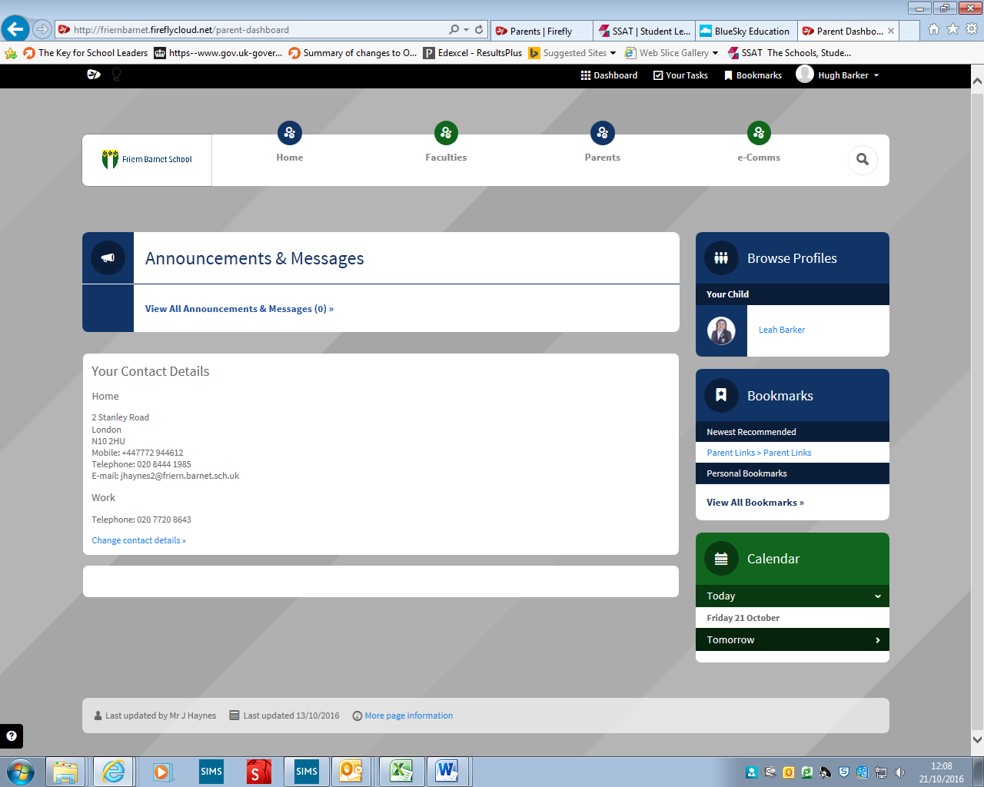
Your contact details – this displays the information we have on our school system. If it’s incorrect then we need to know. It’s simple, just click on the change contact details and we will receive an automated email with the new details

Your contact details
Your child’s profile – click on this link to access your child’s timetable and their home learning

2 The dashboard also includes three other areas
School calendar – week by week events displayed
- Faculties – this is where subjects create useful resource pages to support students learning. All faculties are continuing to develop their pages but you will see resources for year groups and links to home learning in this area. They are not the end product. Teaching staff will be developing these throughout 2016.17 as Firefly is new and will reflect recent changes to curriculum content.

- Parents – this is your place to go for
- Parent mail – one click and you can log into your account, especially useful for cashless catering
- Parent evening booking system – one click and you can log in via your child’s name and date of birth
- Help page – guidance on logging into the different systems
- You will see additional information appear in the parent tab next half term including guidance on assessment and reporting, examinations, enrichment activities and home learning.

- E-comms – this is the new place for our school newsletter and is also where copies of other letters (whole school or year group) will be kept.

Part 2 – activating your account

Logging in for the first time
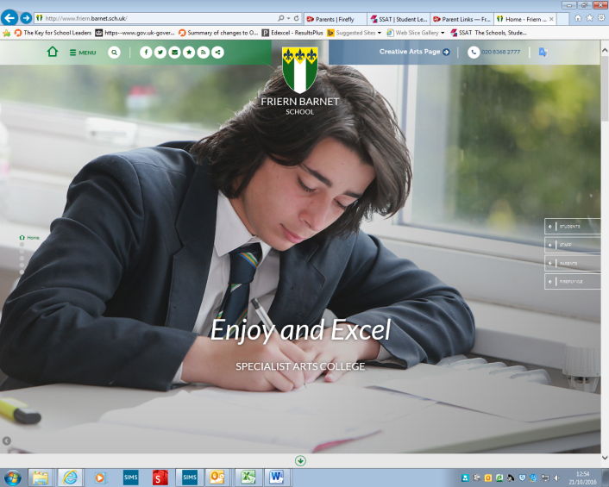
Step 1 - Set up your password and log in to see information about your child/ren at school.
Go to the school website (www.friern.barnet.sch.uk) and select the ‘Firefly VLE’ tab and ‘activate parent account’.
You can use any device: PC, Mac, iPhone, iPad, Android phone, etc.

If using a tablet or phone you will need to click on the green square at the top to get the menu offer.

Only a parent can log in with the email address that we have recorded on our system for your child. If you need to change your email address then please email school@friern.barnet.sch.uk with your new address and we will amend our records. You will then need to follow the steps to activate your account. If you are experiencing difficulty with activating your account, contact us at school on the same address and we will try to resolve.
Step 2 - Activate your account
Follow the on screen instructions and enter the email address that the school already holds on record for you, and select Activate account.

You will only need to do this the first time that you log in.

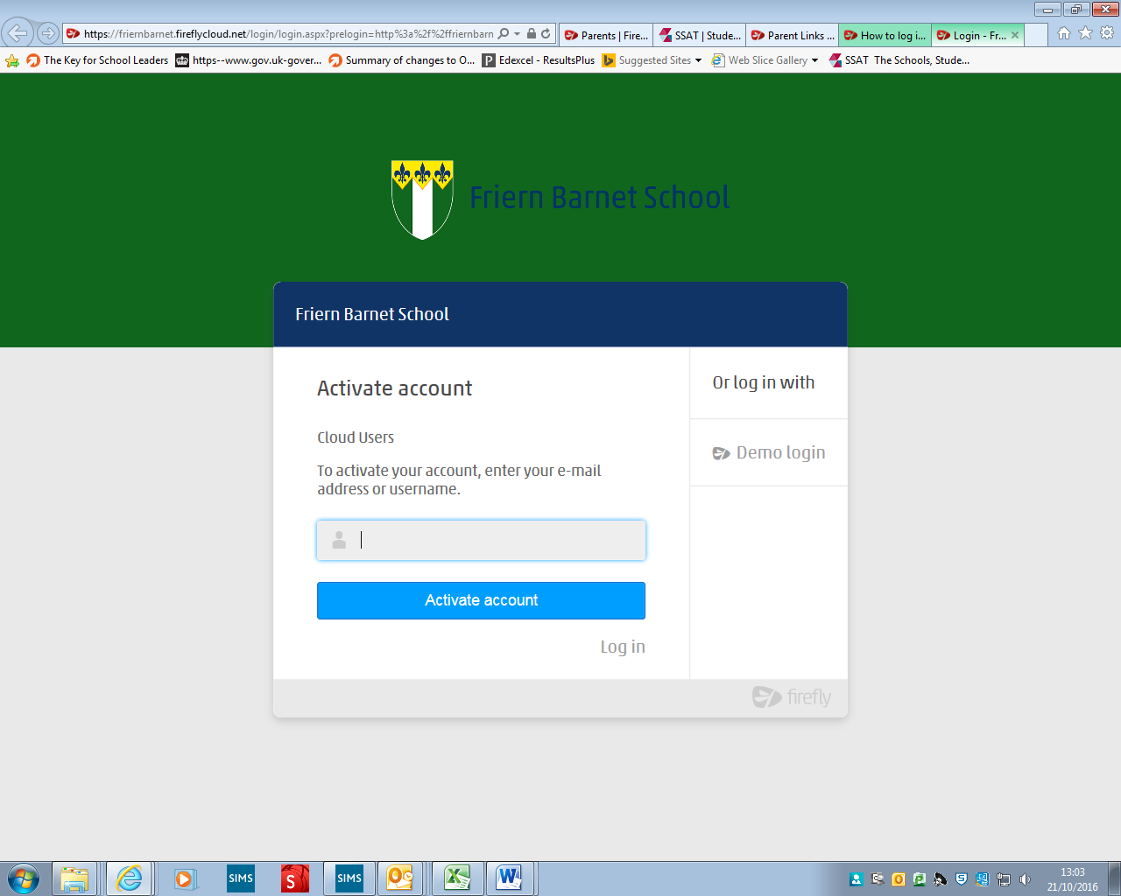

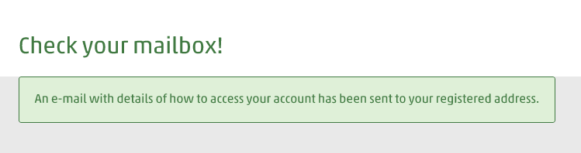
Step 3 Check your email
The Parent Portal will then send you an email. Please check your junk filters if you do not receive the email.

Step 4 - Select the link that appears in your email
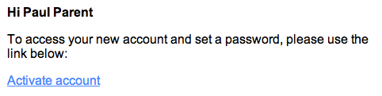

Step 5 - Create and confirm a password
The password is one of your own choosing. You can be reminded of it or change it at any time.
Step 6 - Choose Activate Account
You will now be logged in to the parent portal. The next time you log in with your parent account, simply use your email and the new password you have just created.
Congratulations. You can now log into the Firefly parent portal and can take a look at the site.
Firefly is a tool that we have invested in for our students, staff and parents. We believe it has the potential to be a powerful tool for each user in supporting student achievement and strengthening communication between home and school.
During the next half term, we will run a parent information evening on how to use Firefly to support your child – so please look out for the date in the announcement and messages section of Firefly.
Good luck with your activation.
Yours sincerely

Jane Mullan
Senior Deputy Head Teacher

