Getting started with your Windows laptop

How to turn it on:
- Plug in your device to the mains, using the power supply and charger supplied.
- Press the power button

How to log in:
- You will automatically be logged into the account “localuser”
- If not then select the “localuser” account in the bottom left and click the Sign In button.

Connect to Wi-fi
Your device needs to access a Wi-fi network before you can use the internet:
- Click the round globe Network icon on the taskbar. If you don’t see it click the ^ symbol and you should see it there.
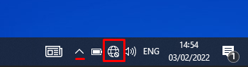
- Select your Wi-fi network , the select Connect. Type in the password and select Next. You should choose No when asked if you want your device to be discoverable on the Wi-Fi network.

Use Microsoft Edge
Your laptop does not come with Google Chrome Browser, please use Microsoft Edge shown in the icon below.
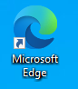

Setup your Microsoft Office Apps
- Open the Start Menu and open one of the Office Apps e.g. Word, Excel or Powerpoint:
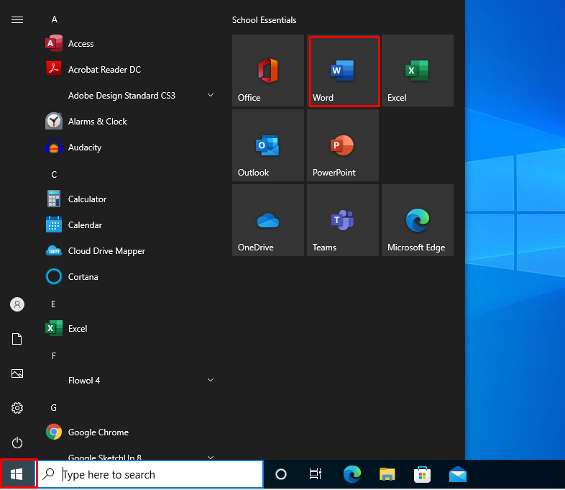

- Click on “Sign in”:
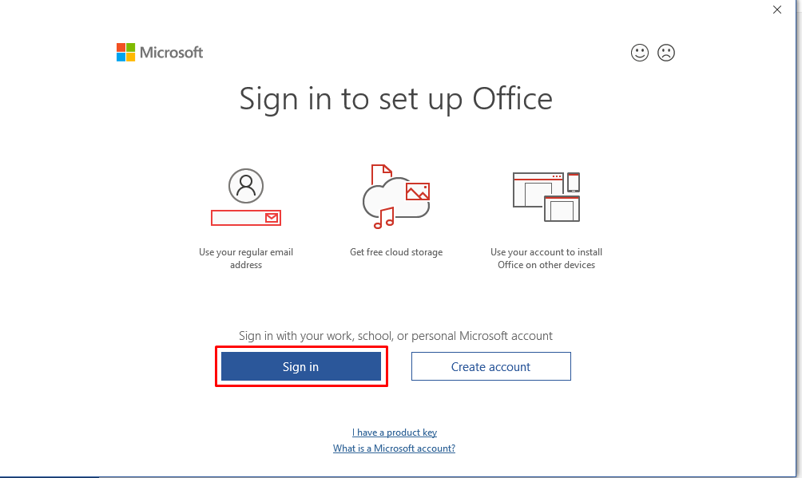
- Type in your school email address (e.g. username@student.friern.barnet.sch.uk) and select Next. Don’t use your personal email as this will not work:
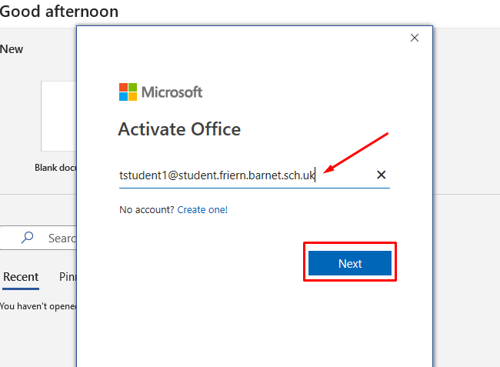
- Type in your email password then select Next. This is always the same password you use to log on to a school PC.
- Click on OK on the “Stay signed in to all your apps” page. When it is finished click on Done.
- Click on Accept if you see the “Accept the license agreement” box.
- If you see the “Default File Types” box, select Open XML Formats and press OK.
- Office is now setup and you can use any of the apps on the laptop.

Access the Internet and Firefly
- Windows comes with Microsoft Edge browser which can be used to access websites. Just search for it in the start menu or open the desktop shortcut:

- When you first try to use the internet at home you will see the screen below. Make sure to select the “Sign in with Microsoft” option:
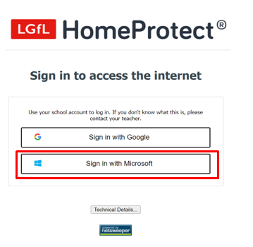

- Log in with your school Microsoft 365 account as you did above when setting up your Microsoft Office 365 Apps. Your email will look like this: username@student.friern.barnet.sch.uk and your password is the same as your school computer login.

- To access your homework and student resources in Firefly, open Microsoft Edge and go to: https://friernbarnet.fireflycloud.net

- You should select the Login with Office 365 option to log in:

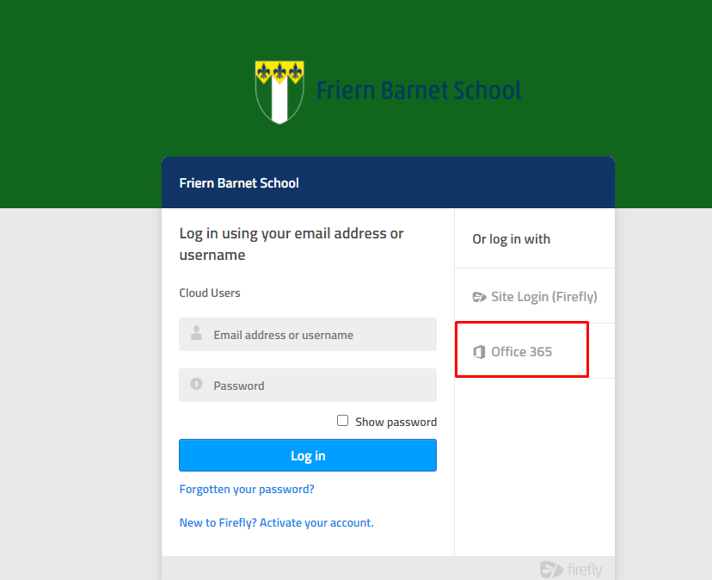

- Type in your school email address (e.g. username@student.friern.barnet.sch.uk) and the same password you use to log on to a school PC.

- You will find links to Office 365 Apps, Email, Onedrive and more in Quick Links on your Firefly dashboard:

